**Master Functional Document**

|  |  |
| --- | --- |
| **Application** | NGERP – Centra |
| **Service Bundle** | Master Management |
| **Service Request** | Department |

**Description:**

In Compiere **(NGERP – Centra)** ,the Department feature helps manage departments within an organization and track costs. It includes name, description, search key, active status, and charges like shipping or handling.

**Workflow Process:**

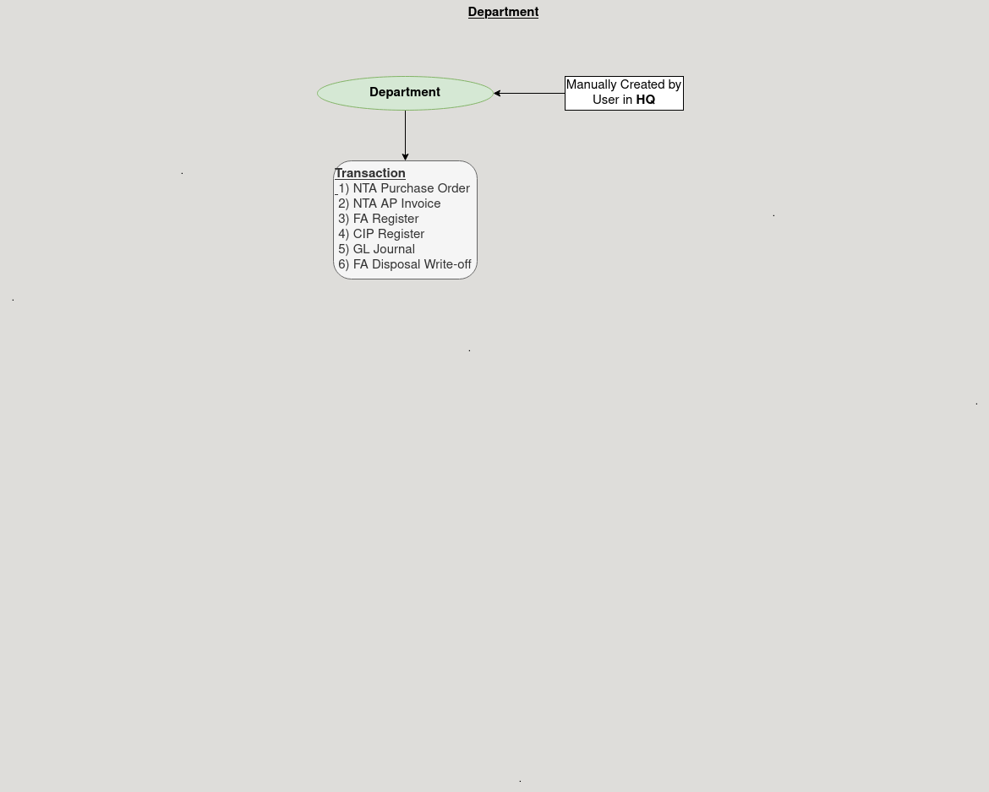

**Business Rules:**

* The Department is only visible in HQ, not in ROW
* Creation of Departments is only possible in HQ.
* Each Department must have a unique search key.
* A Department can be active or inactive for future use.
* Departments are linked to a Company and Branch.
* Charges like handling or shipping can be assigned to the department.